**Creating a Managed Service Account**

You must run this first… warning link says in production environment to wait 10 hours. Refer to the link in a production environment for another method. This forces it to not wait 10 hours:  
<https://social.technet.microsoft.com/Forums/ie/en-US/82617035-254f-4078-baa2-7b46abb9bb71/newadserviceaccount-key-does-not-exist?forum=winserver8gen>

**Add-KdsRootKey –EffectiveTime ((get-date).addhours(-10))**

* <https://docs.microsoft.com/en-us/previous-versions/windows/it-pro/windows-server-2008-R2-and-2008/dd391964%28v%3dws.10%29>
* 07/01/2012
* 2 minutes to read

Applies To: Windows Server 2008 R2

This topic explains how to use the Active Directory module for Windows PowerShell to create a managed service account. Managed service accounts are used to run various services for applications that are operating in your domain environment.

**Example 1**

The following example demonstrates how to create a service account, SQL-SRV1, in the container Managed Service Accounts in the Fabrikam.com domain:

**New-ADServiceAccount -Name SQL-SRV1 -Path "CN=Managed Service Accounts,DC=FABRIKAM,DC=COM"**

**Example 2**

The following example demonstrates how to create a service account, SQL-SRV1, in the container Managed Service Accounts in the Fabrikam.com domain:

**New-ADServiceAccount SQL-SRV1 -AccountPassword (ConvertTo-SecureString -AsPlainText "p@ssw0rd" -Force) -Enabled $true -Path "CN=Managed Service Accounts,DC=FABRIKAM,DC=COM" -ServicePrincipalNames "MSSQLSVC/FABRIKAM-SRV1.FABRIKAM.COM:1456"**

**Additional information**

You can use the following parameters when you set many of the common values that are associated with creating a managed service account:

* AccountNotDelegated
* Enabled
* HomePage
* ServicePrincipalNames
* TrustedForDelegation

For a full explanation of the parameters that you can pass to **New-ADServiceAccount**, at the Active Directory module command prompt, type **Get-Help New-ADServiceAccount –detailed**, and then press ENTER.

<http://www.zeda.nl/index.php/en/>

**Managed service accounts**

Years ago I learned to accept the fact that you sometimes just need to have service accounts with never-expiring passwords. Until Microsoft launched Windows 2008 R2 that is.

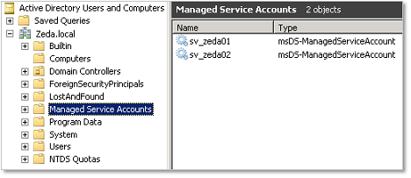

Managed Service Accounts (MSA) allow you to eliminate those never-expire-service-accounts. An MSA is a special domain account that can be managed by the computer that uses it. That computer will change its password periodically without the need of an administrator.

**Prerequisites**

To use Managed Service Accounts you must meet the following requirements:

**Domain:**

* functional level Windows Server 2008 R2

Active Directory Users and Computers will show you a container called Managed Service Accounts just below the root of the domain.

**Server or client on which the account is created or used:**

* Windows 2008 R2, Windows 7 or higher
* .NET Framework 3.5x or higher
* Powershell
* Active Directory module for Windows PowerShell

**Create a Managed Service Account**

There’s no GUI tool that you can use, but the powershell command is easy. Just open Active Directory Module for Windows Powershell and execute the command:

**New-ADServiceAccount [accountname]**

After this the account will be available in ADUC in the container Managed Service Accounts.

**Install a Managed Service Account**

To use the MSA you have to install it on the computer. To do this run the following command with Active Directory Module for Windows Powershell.

**Install-ADServiceAccount [accountname]**

**NOTE:** On Windows 2008 R2 and Windows 7 you can use a MSA on one computer only. On Windows 8 it will be possible to use it on multiple computers.

**Configure a service**

To configure a service to logon with the Managed Service Account just open the service’s properties tab Log On and search for the account like you normally would, but make sure the password boxes are left empty. You will notice that a $ sign is added to the account.

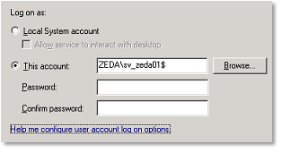

This post applies to: Windows 2008 R2, Windows 2012.